

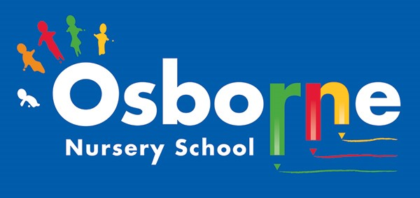

Federation of Osborne and Featherstone Nursery Schools
SEND Information Report
2026-2027

Our Schools & Special Educational Needs:
At Osborne and Featherstone Nursery Schools we support children with a range of differing special educational needs and pride ourselves on being highly inclusive nursery schools with an ethos that encourages and celebrates diversity and difference.
We are fully inclusive settings and work with families and a range of professionals to integrate children with a broad range of needs.
Special Educational Needs and Disabilities (SEND) is categorised into the following areas in the SEN Code of Practice (2014):

Communication and Interaction
Cognition and Learning
SEMH
Physical and Sensory









Who can I talk to about my child's Special Educational Needs or
if I have concerns about my child’s development?
Our SENDCo is Alison Hollins Our SEND Governor is Samantha Carter
Alison works with children, staff, parents and agencies across our two schools to ensure that all pupils' needs are met.
The SENDCO will explain everything to you and make sure that you understand what is happening. We always encourage you to speak to your child's key worker too.
We share information honestly and the door is always open for you to talk to any member of our team.
If you would like to contact Alison, please call 0121 675 1123 (at Osborne) or 0121 675 3408 (at Featherstone)
or email a.hollins@osbornen.bham.sch.uk / a.hollins@feathern.bham.sch.uk

Identifying and Assessing Needs:
- There are several sources of information we use in the identification and assessment of children with special educational needs:
- Parents inform us when registering their child of any additional needs they know their child has;
- Some children may be referred by other professionals.
- If a child enters the setting without any prior concerns, teachers and other staff may identify needs through observation and assessment against age related expectations within the EYFS. This would first be discussed with parents, and they then would then be referred to the school’s SENCo who will co-ordinate any extra support required. We may seek support from external agencies depending on your child’s needs.
- We would then follow the graduated approach:
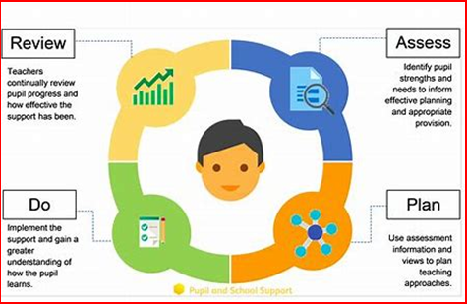

Teaching and Support for Children with SEND:

How are children with special educational needs taught?
As inclusive schools we believe that children learn best alongside their peers, with access to the full EYFS curriculum. We work closely with parents and professionals to identify children's unique skills, needs and how they can best be met within the mainstream environment. Depending on the child's needs, different teaching strategies and resources will be employed including 1:1 support, small group work or support plans developed for a child's unique needs.

Our environments are fully accessible and reflects our ethos of developing children's independence through self-selection and following children's interests. Therefore, the curriculum and environment will reflect children's learning and be adapted to suit particular requirements. We provide adapted resources that allow all children to access the curriculum. Children are supported to develop social skills, become independent and learn how to manage their feelings. Children are also supported to understand appropriate behaviour and to develop confidence in themselves.

How do you approach teaching children with SEND?
Through the graduated approach practitioners will use a wide range of strategies. These may include:
• Visual timetables, photographs, choice boards, object cues, Makaton signs and symbols.
• Differentiated support—learning groups, enhanced adult ratios, or small groups.
• Language and nurture groups.
• Sensory and physical resources.

Have staff had any training around specific needs?
In recent years staff have had training around:
Speech and language difficulties, Autism, Down Syndrome, Cerebral Palsy, Diabetes, Sickle Cell, Asthma, Allergies, Emotion Coaching, Inclusive Practice, Safer Handling and Behaviour Management.
When the school receives a registration from a parent, the SENDCo will arrange appropriate training for staff that will be working with the identified child.

Curriculum Adaptations:
We use a range of strategies to ensure we offer an inclusive approach to learning and allow all children to access the whole nursery environment.

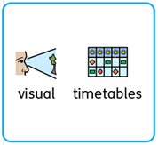
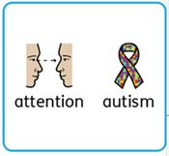
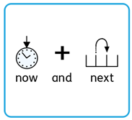

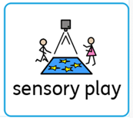
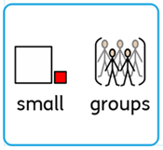
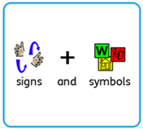


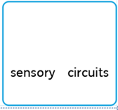
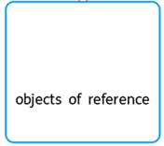
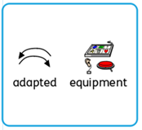


How Do We Evaluate Provision and Outcomes?

We are committed to ensuring that all children with special educational needs and/or disabilities (SEND) receive high-quality support tailored to their individual needs. We regularly evaluate our SEND provision and outcomes by:

- Tracking Progress: We use our nursery’s assessment systems to monitor each child’s progress from their starting points. This involves regular observations, learning journals, and assessment against the Early Years Foundation Stage (EYFS) outcomes.

- Reviewing Interventions: We review the impact of targeted interventions and support plans at least termly. Adjustments are made based on what is working well and what could be improved, in partnership with parents and carers.

- Pupil and Parent Voice: We gather feedback from children (through observations) and from parents/carers to ensure their views inform our provision.

- Staff Collaboration: Regular meetings between the SENDCO and classroom staff ensure that everyone is aware of each child’s needs and progress, and that strategies are consistent.

- Working with Outside Agencies: Where appropriate, we work with external professionals (e.g. speech and language therapists, educational psychologists) and use their recommendations to inform our provision.

Expect A Partnership Approach — Co-production with Parents:

How else do we work with parents?
There are regular opportunities for parents to come into nursery and attend:
- Communication and numeracy workshops -
- Nursery rhyme and story sessions
- Stay and play sessions
- Coffee mornings where parents can meet with outside agencies for further advice and support.

Outside Agencies:
We work with the following agencies to provide support for children with SEND:
- Language, Learning and Strategic Support,
- Communication Autism Team,
- Birmingham Educational Psychology Service,
- Speech and Language Therapy,
- Sensory Support Team,
- Physical Support Team.
We will ask your permission before we arrange for any outside agencies to come in and work with your child.

Will I get regular updates on how my child is doing and how will my child be assessed?
We have an open-door policy and encourage parents and carers to share with staff their child’s successes and needs. In the same way keyworkers will communicate daily with parents and carers about how the children are doing at nursery.
Parents and carers also have access to their child’s on-line Tapestry learning journal which records observations, photographs and assessments of their child and on which they can comment and leave their own observations. All children's progress is monitored against age expectations within the EYFS and against baseline assessments carried out when the child enters the nursery.
Termly meetings with parents and any other professionals working with your child will take place to evaluate the impact of these interventions and new plans will be agreed following each meeting.
If attainment is below age expectations or progress from their baseline is poor, additional interventions will be put in place.

Expect A Partnership Approach — Pupil Voice:

In our schools, every child’s voice matters. We are committed to listening to our children with special educational needs and disabilities (SEND), ensuring they are included in decisions about their learning and care.
How we gather pupil voice:
- Observing play and interactions
- Using visual aids (e.g., happy/sad emotion cards)
- One-to-one or small group conversations
- Communication aids for non-verbal children
How pupil voice shapes support:
- Setting personalised learning targets
- Adapting support plans and the nursery environment
- Ensuring all children’s preferences and dislikes are considered
Supporting all children:
- Visual prompts, signs, and routines to encourage expression
- Staff trained to interpret non-verbal cues
Review and feedback:
- Regular reviews in staff and key worker meetings
- Changes made based on children’s feedback
Parental involvement:
- Working closely with parents/carers to understand and represent their child’s views

Expect A Partnership Approach

We work with outside agencies who can provide a specialised service to ensure every child’s needs are met appropriately. We will always talk to you if we feel that your child needs support from an outside agency and we will ask for your permission to involve them.

Occupational Therapy
Supports children with physical/sensory issues which impact on their independence and self-care.

Speech & Language Therapy Service (SALT)
Supports children with speech and language difficulties.

Educational Psychologist (EP)
Supports children who have social, mental or emotional needs, or other complex needs.

Language, Learning & Strategic Support (LL&SS)
Work with educational settings to help pupils with cognition, learning, and language difficulties.

Communication & Autism Team (CAT)
Supports children who are being assessed for, or already have, a diagnosis of Autism or communication difficulties.

Sensory Support Teams
Specialist educational service for children with hearing loss or vision impairment.

Health Visiting Team
Supports children with developmental and medical needs, including where medication is prescribed/required.

Physical Support Team
A specialist inclusion service that supports children with physical difficulties and complex medical needs in mainstream schools and nurseries.

Physiotherapists
Supports children affected by injury, illness or disability through movement and exercise, manual therapy, education and advice.

What support is in place for my child’s transition to primary school?

We understand that moving on to primary school is a significant milestone, especially for children with special educational needs and disabilities (SEND). We are committed to ensuring every child experiences a smooth and supportive transition.
Preparation and Planning:
- In the spring and summer terms, we identify children who may benefit from additional transition support.
- We work closely with families to understand each child’s unique needs and preferences.
Collaboration:
- With parental consent, we share relevant information about each child’s strengths, needs, and successful strategies with their new school.
- We arrange transition meetings with the receiving primary school’s SENCO and, where appropriate, involve external
professionals (e.g., speech and language therapists).
Personalised Support:
- We can arrange visits to the new school and provide visual supports such as photo books or social stories about their new setting.
Involving Parents and Pupils:
- Parents and carers are invited to meetings to discuss transition arrangements and share their insights.
- We encourage children to share their feelings and questions about starting primary school, using age-appropriate
methods.
Follow-up:
- We remain in touch with families and the receiving school during the first term to ensure a successful transition.
Contact:
- For questions about transition support, please contact Alison, SENCO, via the school office.

Further Information:

How Do I Raise a Complaint About SEND Provision?
We and our Governing Body take complaints seriously and will act upon these on an individual basis.
Concerns about your child’s SEND learning needs and/or provision should be made to the class teacher or SENCO in the first instance.
If the problem is not resolved, we operate a complaints procedure, details of which can be found in the ‘Policies’ section of our website. Alternatively, you can request a copy of our complaint’s procedure at the school office.

Where is the Local Authority’s Local Offer published?
The local authorities local offer can be found at:
https://www.localofferbirmingham.co.uk/

Where Can I Access the SEND Code of Practice?
SEND code of practice: 0 to 25 years - GOV.UK

Your GP and local Health Visiting Team can also provide further advice and support if you have any concerns surrounding your child’s development.

